3D1 The Bipolar Junction Transistor Inverter

**Alexandru Sulea**

**suleaa@tcd.ie**

**Std no: 12315152**

**[Type the fax number]**

**[Pick the date]**

3C2 Digital Circuits

# Introduction

The purpose of the D1 laboratory is to examine the properties and functions of a Bipolar Junction Transistor using MultiSim. The experiments will encompass the topics covered in the lectures and seek to expand our knowledge of active electronic devices in both analogue and digital applications.

# Apparatus

The only apparatus used in this lab was the MultiSim in the Printing House Comp. Room. Though MultiSim 13.0 can simulate a thousand plus different electronic components we only needed it to simulate 7 distinct components:

A resistor, the ground component, the Pulse voltage, DC powers component, DC current component, the 2N2222A and 2N3904 BJT model.

# Background Concepts

A bipolar transistor is comprised of three layers of doped semiconductor materials , this can take the form of either a p-n-p or n-p-n setup. The only difference between the two is the direction of the current flow

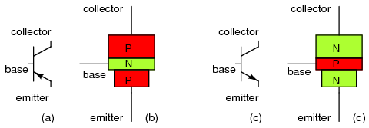

(Ref.3)

Bipolar transistors are named as such because their operation involves both holes and electrons. Electrons are majority charge carriers in n-type semiconductors, whereas holes are majority charge carriers in p-type semiconductors. In contrast, unipolar transistors such as the field-effect transistors have only one kind of charge carrier.

A bipolar junction transistor is a type of transistor that relies on the contact of two types of semiconductor for its operation. BJTs can be used as amplifiers, switches, or in oscillators. BJTs can be found either as individual discrete components, or in large numbers as parts of integrated circuits.

Charge flow in a BJT is due to diffusion of charge carriers across a junction between two regions of different charge concentrations. The regions of a BJT are called emitter, collector, and base. A discrete transistor has three leads for connection to these regions. The first n-region specified as n- is lightly doped and diffused into the substrate to form the collector region. This is followed by a very thin p-type region which forms the base that is moderately doped .Typically, this is topped by a heavily doped, n- region called n+  which forms the emitter region, By design, most of the BJT collector current is due to the flow of charges injected from a high-concentration emitter into the base where there are minority carriers that diffuse toward the collector, and so BJTs are classified as minority-carrier devices.(Ref. 1)

The bipolar junction transistor may, in fact, be operated with its base-emitter and base-collector junctions in either direction. Though most types of bias found involve the base-emitter junction being forward biased and the base-collector junction being reverse biased this process is commonly known as Forward Active Mode. This is the normal mode of operation of the bipolar junction transistor as an amplifying device. (Ref. 2)

# Experimental Setup

# Results

A.1 Collector Current against Base - Emitter Voltage.

Parameters taken from component 2N2222A:

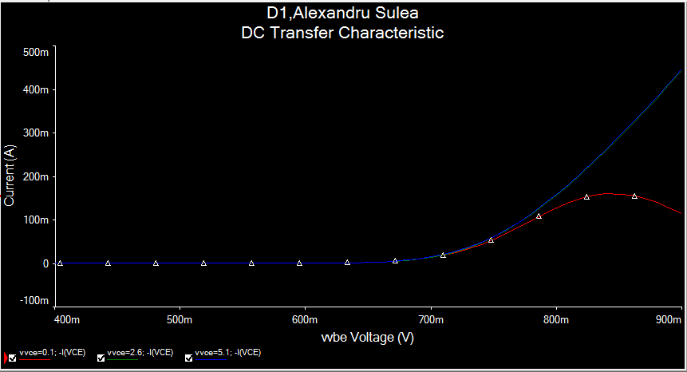

|  |  |
| --- | --- |
| Bf, the forward gain (βF) | 220 |
| Br, the reverse gain (βR) | 4 |
| Tf, the forward transit time (τF) | 0.325ns |
| Tr, the reverse transit time (τR) | 100ns |
| Cjc, B-C zero-bias depletion capacitance (CBC) | 9.12pF |
| Cje, B-E zero-bias depletion capacitance (CBE) | 27.0pF |

Vce = 0.1V Transistor Saturated.

Vce = 2.6V Transistor in the Forward Active Region.

Vce = 5.1V Transistor in the Forward Active Region

Vbe cut-in when Ic = 100µA and Vbe on when Ic = 5mA

|  |  |
| --- | --- |
| **Vbe cut-in** | 0.781V |
| **Vbe on** | 0.671V |

A.2 Collector Current vs. Collector-Emitter Voltage.

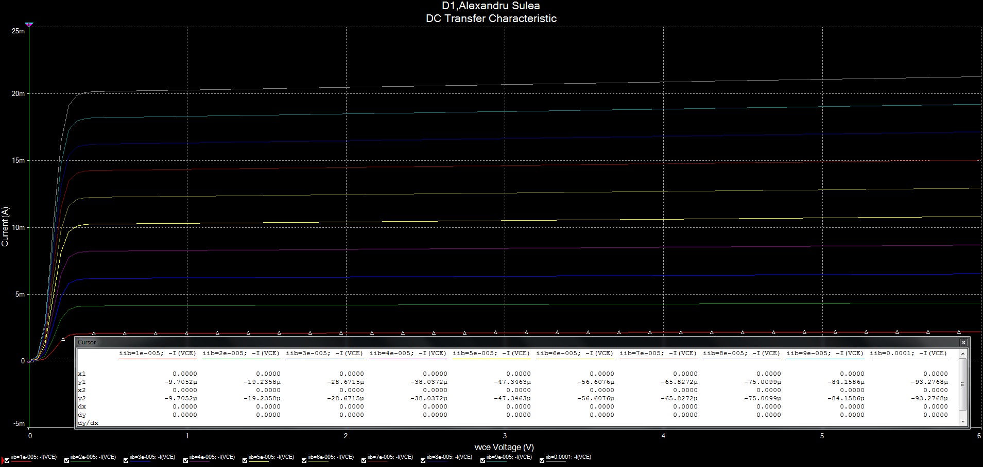

2N2222A Transistor

|  |  |
| --- | --- |
|  | 2500 |
|  | 210 |
|  | 0.246619 V |

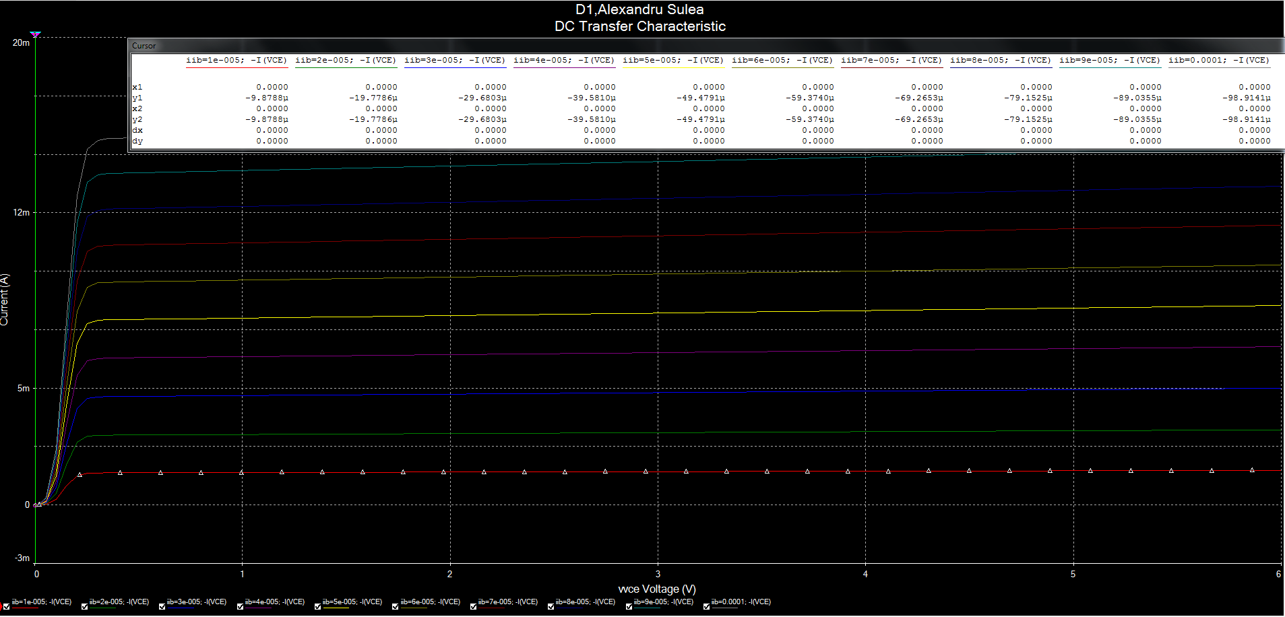

2N3904A Transistor

|  |  |
| --- | --- |
|  | 142 |
|  | 162 |
|  | 0.217414 V |

B. Resistive Loaded BJT Inverter - Transfer Characteristic.

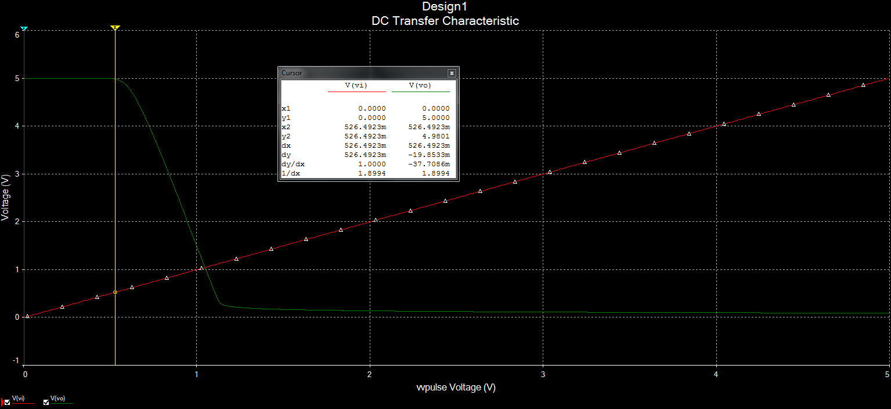

RC@1KΩ

|  |  |
| --- | --- |
| **VOH** | 5V |
| **ViL MAX** | 0.530V |
| **VOL** | 0.291V |
| **ViH MIN** | 1.1337V |

7): Compare these measurements with calculations from theory and previous device measurements:

5V

0.291V

0.530V

1.0990V

8): Predict what will happen if Rc is increased from 1k to 4k.

Ans. Quicker Decay in the wave form.Eg. steeper decline noticed in wave

9): Having closed down the graph, change the value of Rc to 4kΩ.

Re-run the simulation to investigate and record what happens to the transfer characteristic.

Print out the plot obtained for inclusion in your report.

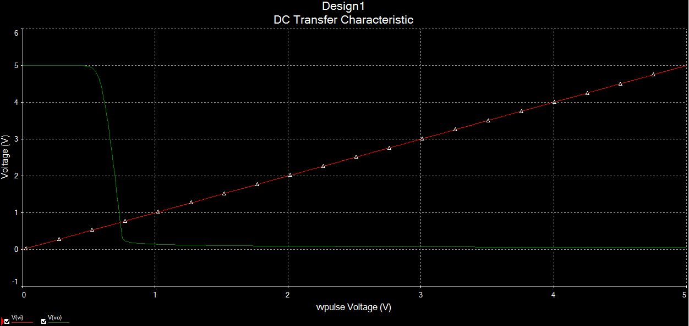

Rc@4kΩ

C. BJT Inverter - Switching Characteristics

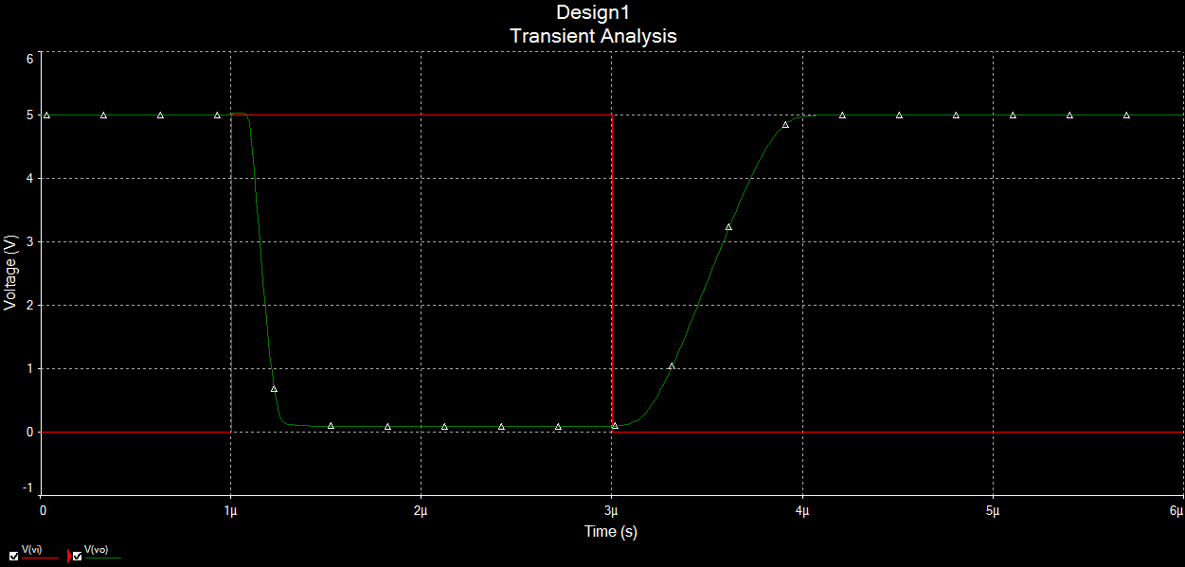

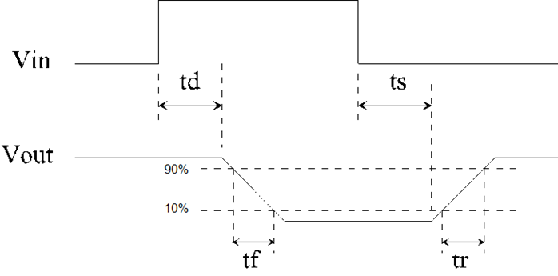

|  |  |
| --- | --- |
|  | 0.0796us |
|  | 0.1293us |
|  | 0.1642us |
|  | 0.592us |

3): Compare the measured values with those calculated from the following analytical equations. You will need the properties recorded for the transistor from the database in the first task carried out in Section A1.

0.0809us

0.0809us





=1.4855X10-7

where 

2.1645X10-4 A



4.709X10-3 A

Then





7.411X10-7 s

where 

-3.355X10-5 A





4.905X10-5 A

Finally



3.827X-10 s

Results filled in table as specified:

|  |  |
| --- | --- |
|  | 8.09X10-8s |
|  | 1.4855X10-7s |
|  | 7.411X10-7s |
|  | 3.827X10-5 s |

The calculated values should be compared with the measured values obtained in the simulation above.

4): Predict what will happen if **Rb** is reduced to **5kΩ** (without calculations).

A change in Rb effects all 4 cycle times and thus if a time is divided by Rb it will now increase. This increase will lead the wave function to look less square , thus the drop off point will look less pronounced and the transition time will thus increase.

5): Change **Rb** in the circuit to **5kΩ** and investigate and record the resulting effects.

|  |  |
| --- | --- |
|  | 2.0236X10-8 s |
|  | 5.743X10-8 s |
|  | 1.423X10-6 s |
|  | 5.855X10-8 s |

6): Predict what will happen if **Rc** is increased to **4kΩ** (without calculations).

Since Rc is responsible for the value of ICMAX a higher value for Rc will mean a decreased value of ICMAX thus giving a smaller value for every time across the board except for td  since it is not effected by ICMAX  or Rc. The drop off point will also become steeper as Vce is raised giving it a square wave look(but not turning it into a square wave ).

7): Change **Rc** in the circuit to **4kΩ** and investigate and record the resulting effects in the table below.

ANS.

The results achieved were taken as only Rc being changed and not Rc together with Rb since reading the Q does not specify specifically at which point to increase RC.

|  |  |
| --- | --- |
|  | **8.094X-8 s** |
|  | **1.162X10-7 s** |
|  | **9.8435X10-5 s** |
|  | **9.550X 10-7 s** |

# Discussion

(i) What are the limitations on the accuracy of your results?

Human error played a big part in discerning the results as subjective viewing was used more than a real form of accurate measurement. Rounding the results also could have led to a small discrepancy between the calculated and observed results.

(ii) How do the values of parameters compare with those obtained in lectures?

The values differed somewhat from those obtained in lectures as the values and diagrams given in lectures represent an ideal state. Whereas in our simulation we noticed that the lines in the transient analysis were not perfectly horizontal.

(iii) What are the advantages or disadvantages of circuit simulations such as the one carried out in the experiment?

The advantages of this simulation were that 3 distinct circuits could be simulated and analysed in a 3hour lab. If were to build the circuits manually it would have taken up substantially more time and resources.

The disadvantages of this simulation is that it lacks the real world aspect of dealing with bipolar transistors. In theory someone can know how to calculate and analyse a bipolar transistor without ever having to know what it looks like which for field associated work may be a huge disadvantage.

(iv) What are the benefits or drawbacks of circuit simulation and of MultiSim in general as applied to the design of electronic circuits?

The advantages of simulating an electric circuit are of course that it saves time and effort. Along with the usual advantages a simulation also allows for quicker modifications of circuit designs and instantaneous simulation of that circuit with a graph.

The disadvantages of the MultiSim simulations are that our virtual environment does not factor in environmentally dependent errors such as temperature and humidity. As we all know heat increases resistance .Thus the simulation can only show how a circuit will behave in ideal conditions but not in adverse ones.

(v) What are the essential elements of good circuit simulation and simulators?

A good simulator should be comprised of a large library of components to choose from and be able to experiment and simulate multiple circuits quickly and efficiently. All the models in the simulation should be accurate and up to date with standard industry components.

A good simulation is comprised of neatly placed components with clear wiring. Tangled wires can cause headaches and increased maintenance times so a clear representation in any simulation is a must. The components should be correctly placed in their positions and clearly labelled, the different attributes of each component (V,Ω etc.)should be known and clearly set.

(vi) What is the role of the Electronic Engineer in this regard?

The role of an Electronic Engineer is to promote the knowledge of electrical engineering in industry and academia, to establish and maintain the standards of professional engineering and professional ethics and conduct. The role also encompasses providing opportunities for continuing professional development in engineers. Thus finally, the role of an electronic engineer is to act as an authoritative voice of the electronic engineering profession in Ireland and abroad.

(Ref. 4)

# Conclusion

The conclusion drawn from completing this laboratory is that the bipolar transistor junction or bjt is a very useful and important piece of in the world of semiconductors. By using MultiSim to cut down on time and analyse the circuits more efficiently a circuit comprising of a bjt was analysed.

Although there were discrepancies between the transient

# References

1. The Art of Electronics-Paul Horowitz and Winfield Hill
2. Lecture Notes
3. <http://www.allaboutcircuits.com/vol_3/chpt_4/1.html>
4. <http://www.engineersireland.ie/About.aspx>